Java compilation and execution
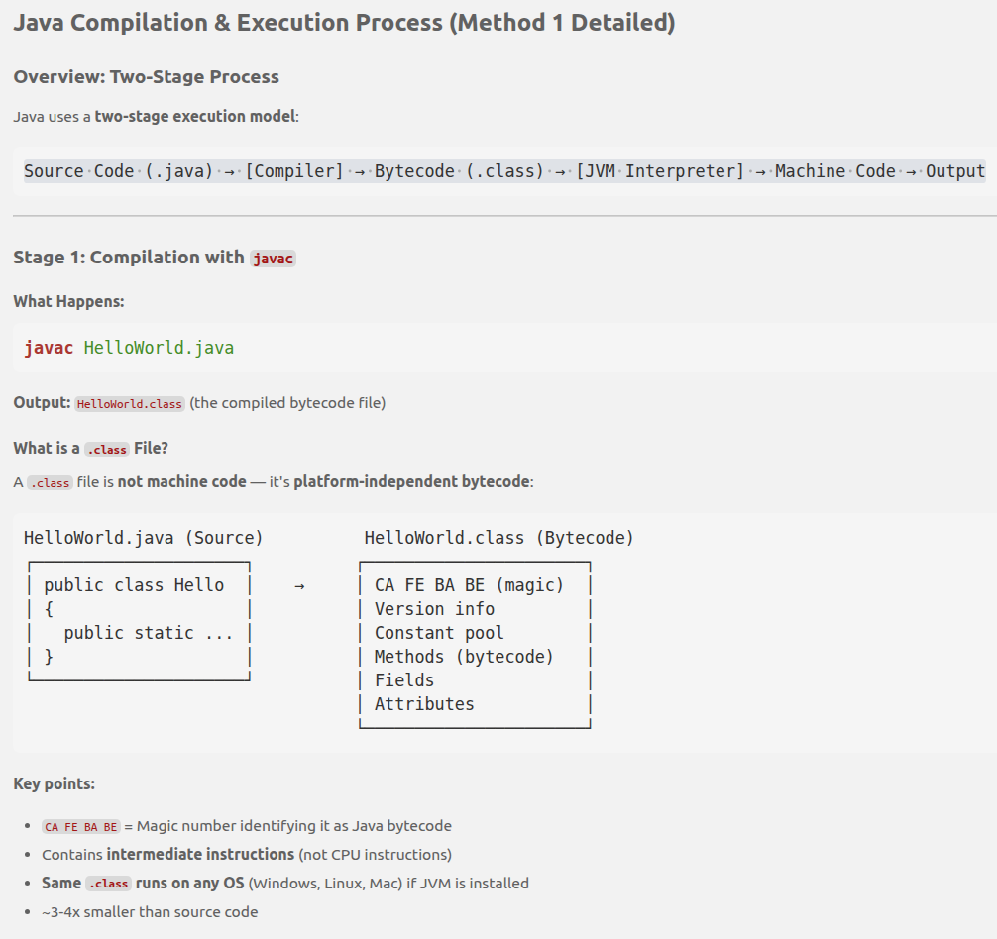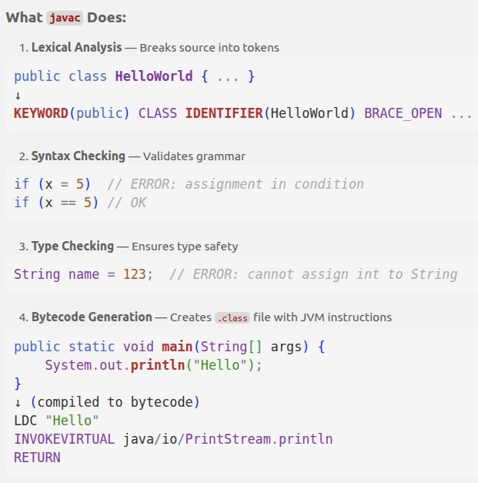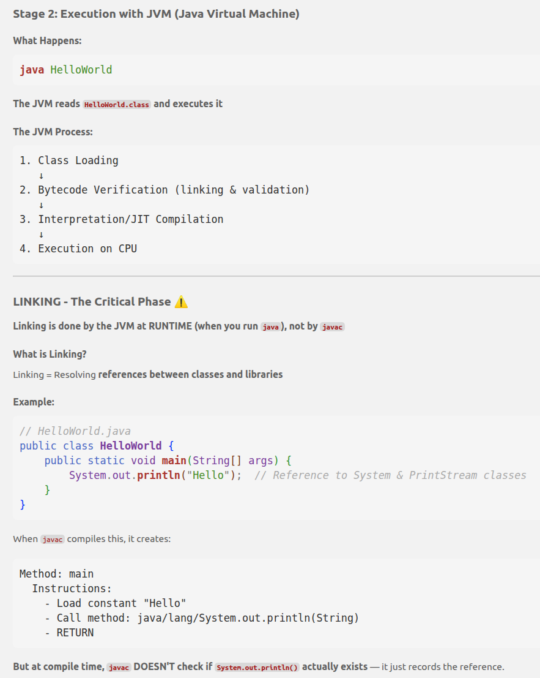

Summary with Example
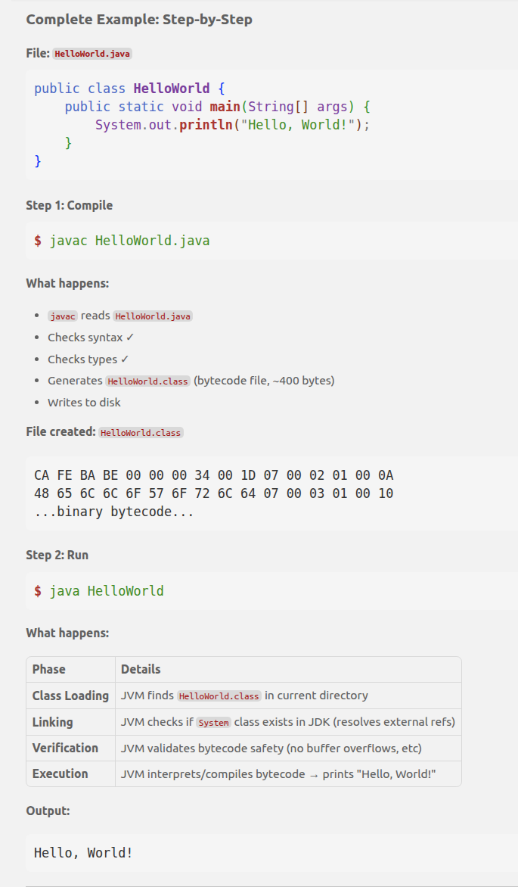

Memory management
General concept that applies to all applications (Whether you write code in C++, C#, Python, JavaScript, or Java)
When, compiled or run on modern operating systems (like Windows, macOS, or Linux), the operating system will always allocate these exact core segments to your application's Process.
Think of RAM (computer's brain (RAM)) as a giant warehouse. To avoid total chaos, the computer neatly partitions this warehouse into specialized sections for each task (Process) given to it.
And inside that section, it organizes its data inside. This is called Memory management.
Video link:
Memory management in Java: https://www.youtube.com/watch?v=aAjkJW08BGQ
Constructor: youtube.com/watch?reload=9&v=Hpg4fBTCYuA
Stack Vs Heap allocation: geeksforgeeks.org/dsa/stack-vs-heap-memory-allocation/
Read: https://notionalmachines.github.io/nms/StackAndHeapDiagram-3.html
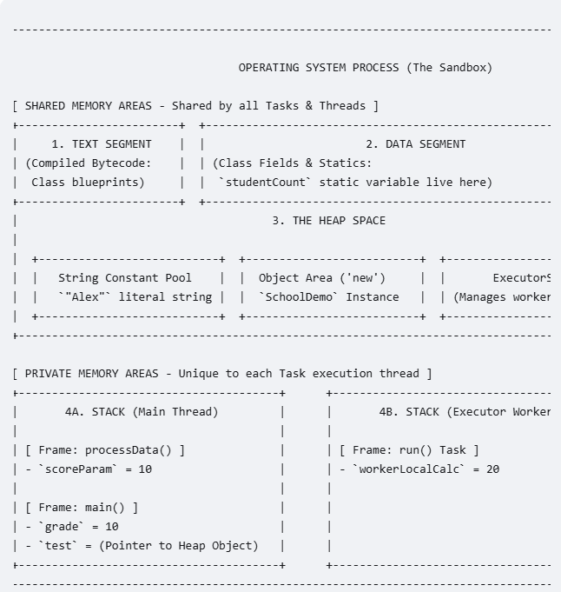 | 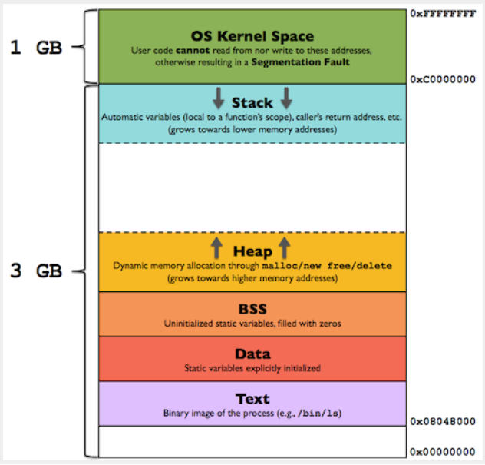

VSCode – Run Java main
When you click "Run" on a java program, the Operating System creates “Process Sandbox” with 4 memory segment and loads the .class (ByteCode, platform independent instructions for CPU) to “Text Segment”. Java Virtual Machine JVM
Text Segment | Contains the compiled bytecode of your program—the actual instructions that the Java Virtual Machine (JVM) executes.
Class is in text segment.
Memory is not allocated until Main creates object from Blue print.
Primitive Data Types vs. Classes  In programming, primitive data types are the basic building blocks that hold simple, single values, while classes are user-defined blueprints used to create complex objects that bundle both data and behavior.  Think of primitive data types as raw materials (like wood, bricks, or nails) and classes as blueprints for a house (which specify how to combine those materials and what the house can actually do). | 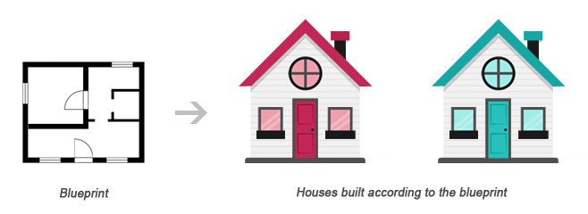
When a class is specified,  1> memory space of all the member function is allocated – in Text segment.  but memory allocation is not done for the data member.  2> When an object is created, memory allocation for its data members is done.  Same member functions but they may be storing different data in their data members. | 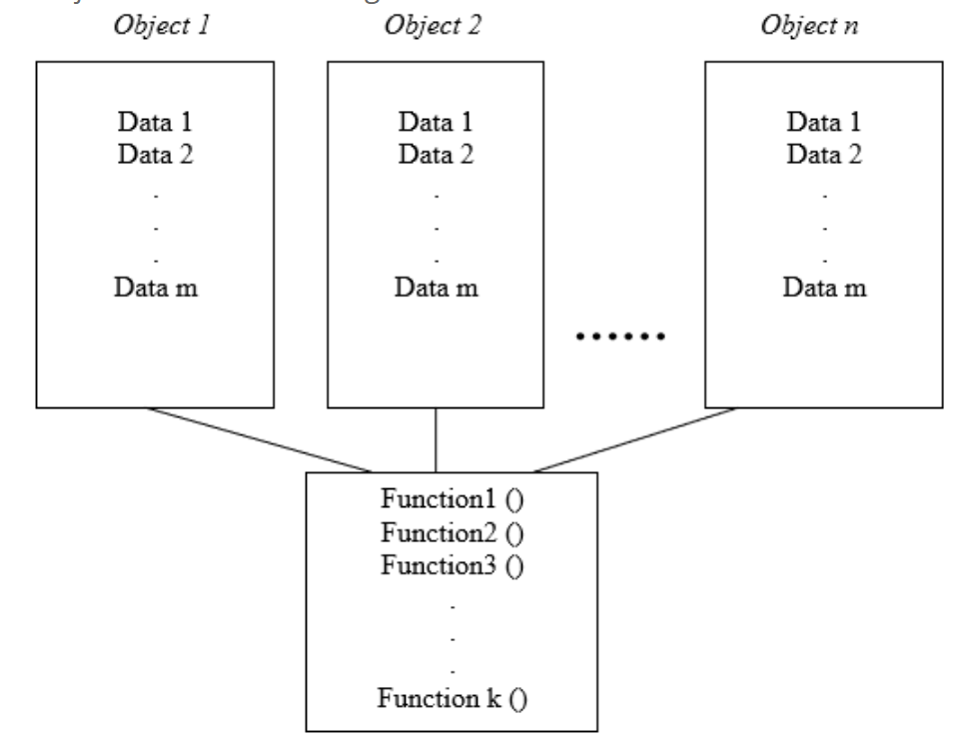
class Car {  public String color;  }  public class Main {  public static void main(String[] args) {  // Anew Car object Allocated on the heap, but its reference is not preserved! (not accesible/referenced) Garbage collection eligible):  new Car();  // Reference type Varaiable (allocated on the stack) (pointing to null)  Car myCar;  // New Car object Allocated on the heap and its reference stored on myCar on the stack.  myCar = new Car();  // New String object allocated in heap and its reference is stored in instance reference variabl color of the object  mycar.color = "Black";  }  } | In Java, most of your day-to-day coding interaction happens dynamically between the Stack and the Heap.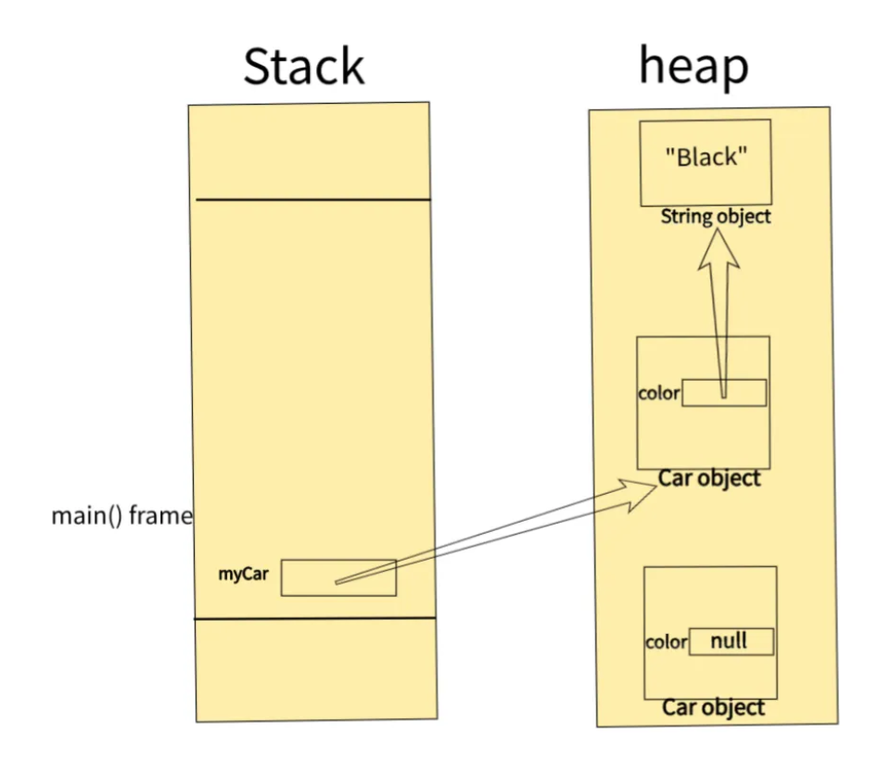
public class Example {  public void stackExample() {  // Stored in the stack  int num = 10;  // Reference is in the stack, but "Hello" (object of class String) is in Heap (in the string pool area)  String text = "Hello";  }  } | 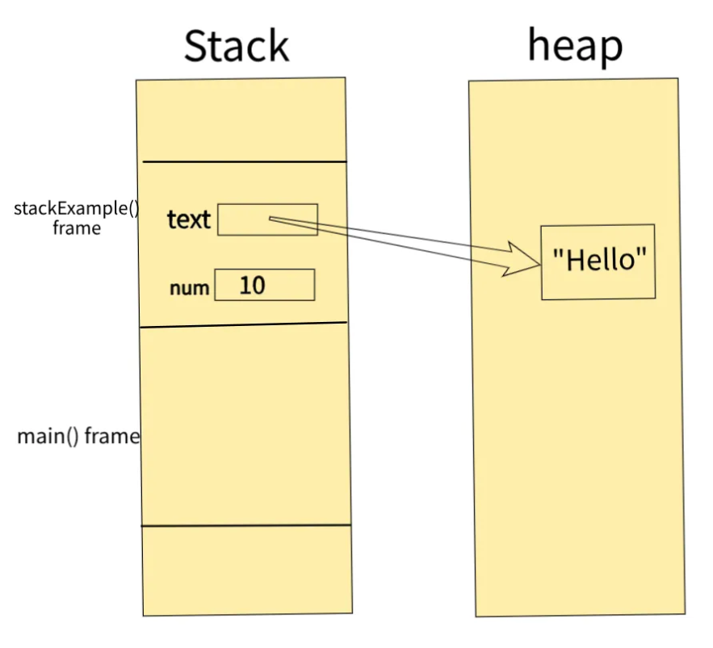
Stack
The Stack is crucial for managing method execution, storing method call frames, local variables, and references to objects in the heap. Each thread has its own stack, providing thread isolation and supporting concurrent execution.
Characteristics of the Stack
- Local Variables and References
- Function parameter
- Maintains methods call stack
- LIFO Memory Management: The stack follows a Last-In-First-Out (LIFO) approach. Each method call adds a stack frame, and the frame is removed when the method completes.

Heap
The Heap is the main memory pool for dynamic allocation in Java, storing all objects created during runtime. Java’s automatic garbage collection handles memory cleanup when objects are no longer referenced, making the heap essential for long-term storage.

Characteristics of the Heap:
Instance Variables and Object Allocation: When you create an object using new, it’s allocated on the heap and reference stored in Stack.

Data segment  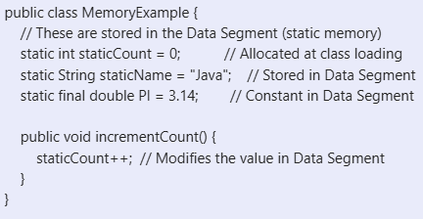  **Key Points:**  - Immutable string literals are pooled to save memory  - Static variables exist throughout program lifetime  Variables created for whole Class (not instance)  - All instances share static variables  - Data Segment is allocated once at class loading | static variables and string literals that exist for the entire program lifetime.  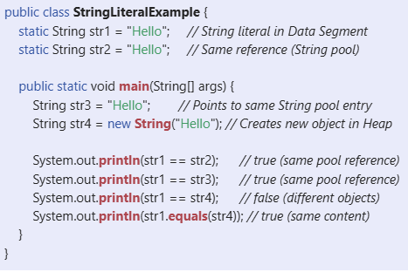
Garbage collection  Once objects lose references (e.g., after a variable goes out of scope), they become eligible for garbage collection. | 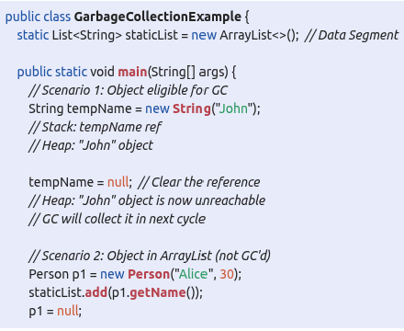
### Memory Leak
// Static collection holds references indefinitely
static List<MyObject> cache = new ArrayList<>();

void addToCache(MyObject obj) {
cache.add(obj); // Added to static list
}
// Objects never removed, never GC'd
// Result: Gradual memory leak

However, the way these segments are managed internally differs depending on the programming language. Here is a direct comparison between Java and standard compiled languages like C/C++:
Memory Segments Across Different Languages

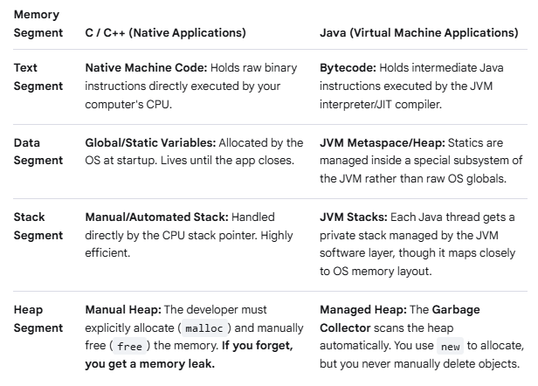
Why Java is Unique
In standard native applications (like a video game written in C++), your app talks directly to the Operating System.
In Java, there is a middleman. When you start a Java application, the OS actually launches the Java Virtual Machine (JVM) process. The JVM pretends to be its own little computer inside your real computer. The JVM takes the broad Text, Data, Heap, and Stack blocks given to it by the OS and manages them via its own interna l software structures to provide helpful safety nets like automatic Garbage Collection.
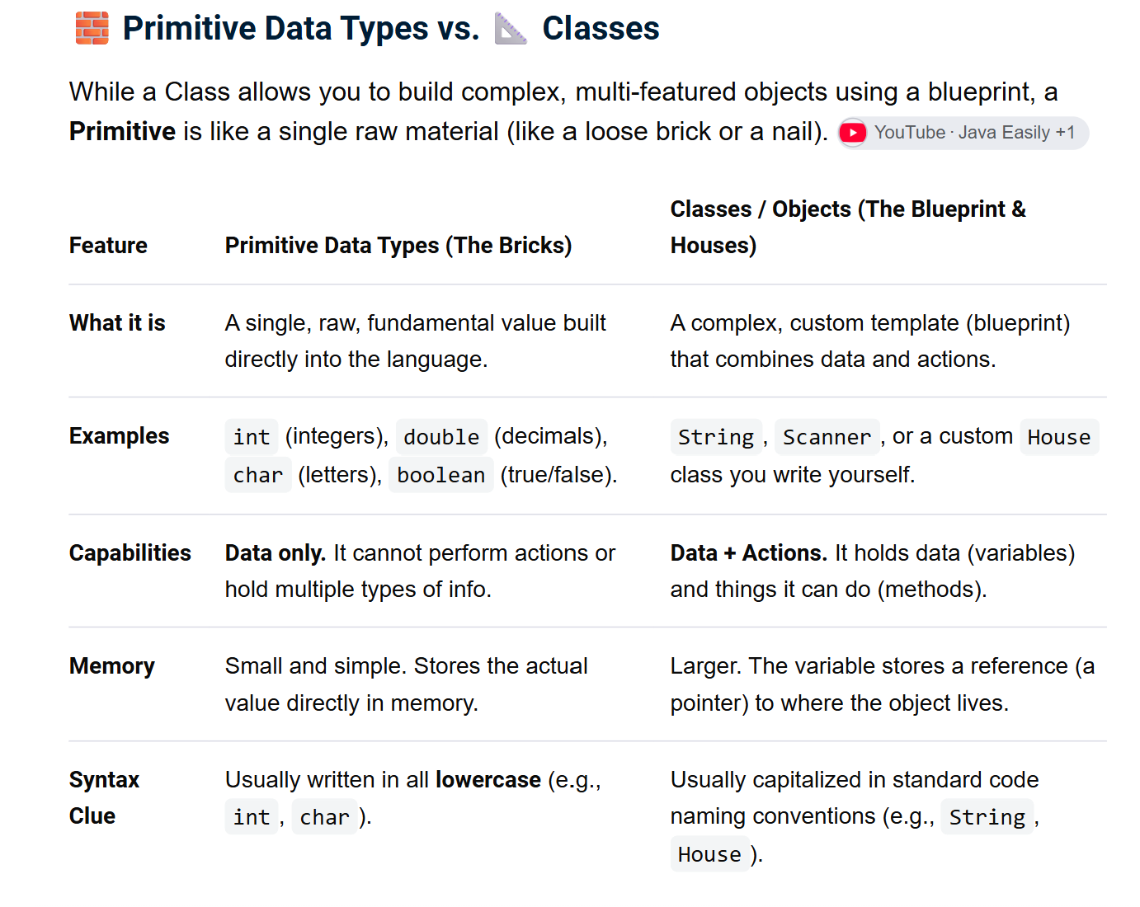
Visualizing Inheritance
Inheritance is organized hierarchically, moving from a general concept down to specific variations. The diagram below illustrates how a general parent class passes its core structure down to specialized child classes:
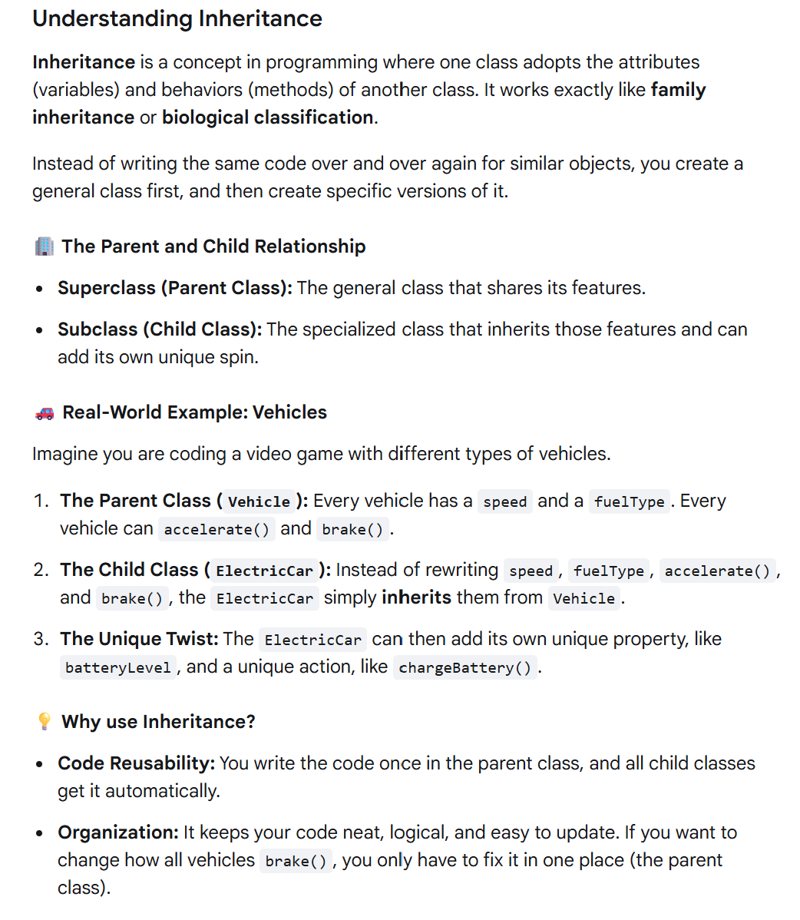
When you create an object from a child class (a subclass), computer memory handles it very specifically: every single object gets its own completely separate, isolated copy of the parent's data variables.
If you change the variable inside one child object, it will not affect the other child object.

The Blueprint vs. Isolated Objects
Think of a class as a template. When you use that template to create child objects, the computer carves out totally separate spots in memory for each one:
Imagine you have a parent class called Vehicle which has a variable called speed. Then you create two distinct child objects from it: car1 and car2.
- Object 1 (car1): Gets its own variable chunk for speed. If you accelerate car1 to 60 mph, only its personal variable changes.
- Object 2 (car2): Gets a completely separate variable chunk for speed. It stays at 0 mph even though car1 is speeding away.

How the Data Copies Work in Memory
When you actually create real objects in your code using these blueprints, the computer carves out completely separate, isolated boxes in memory for each individual vehicle.
Each child object inherits the foundational structures from the Car blueprint, but fills those boxes with its own completely unique values:
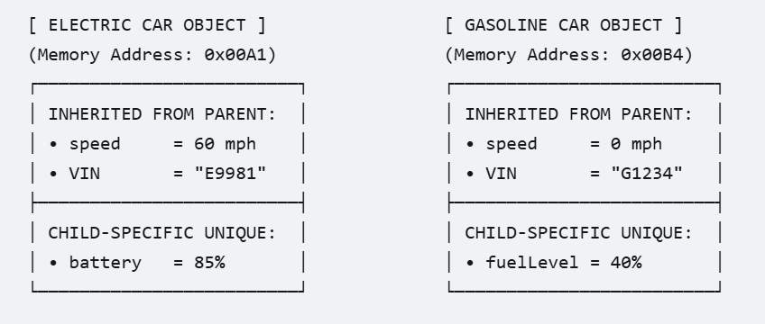
Here is the official Class Diagram for your car hierarchy.
In a standard computer science class diagram, the arrows point upward from the child to the parent to represent the relationship "is a" (e.g., an Electric Car is a Car).

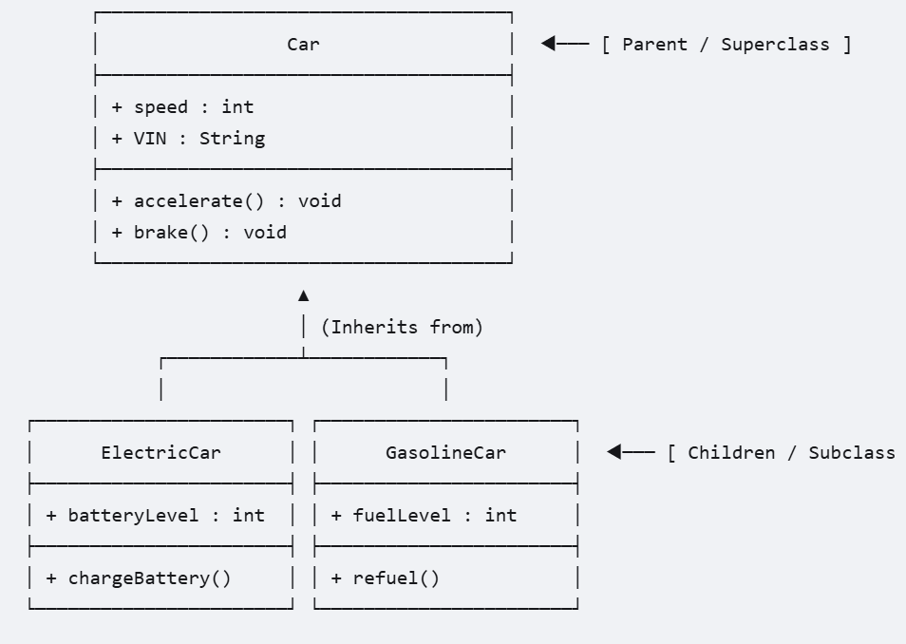
This shows how an OS Process hosts Shared Blocks (Text, Data, Heap) alongside Private Worker Threads (Stacks).
